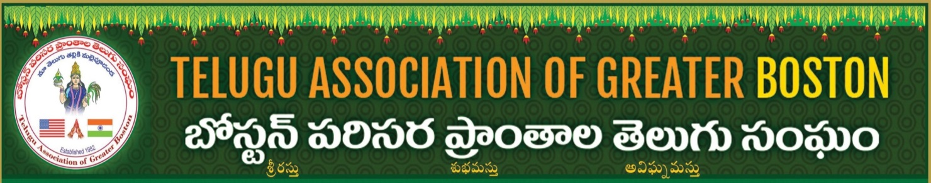
Disclaimer

I / we, the vendor, ______________________________________________________________
expressly releases Telugu Association of Greater Boston (TAGB) from any and all liabilities for damage, injury, loss or theft that may arise or occur to me or my employees, family or goods (or customers while in or around my booth) on the premises during TAGB’s event and agree to the below policies.
If for any reason Vendor does not show up on the Event day, Money or other means of service will be returned/exchanged until there is well Advance notice prior to the Event.
Non Food vendors are not allowed to sell Food/Snacks.
Vendor Tables and Location will be allocated by the TAGB at the event Location, No exchange/moving of tables without TAGB prior approval.
Vendor’s staff must be present at the table at all times during the TAGB event.
Vendors are responsible for removing all wares, recycling and garbage at their TABLE.
TAGB reserves the right to use any photograph/video taken at the TAGB event, without the expressed written permission of the Vendor.
Vendors acknowledge that they are responsible for the information, profiles, opinions, messages, comments and any other content (collectively, the “Content”) that they post on the table at the TAGB event.

Name: - ___________________________________________________________
Place: - __________________________________ Date: - __________________

